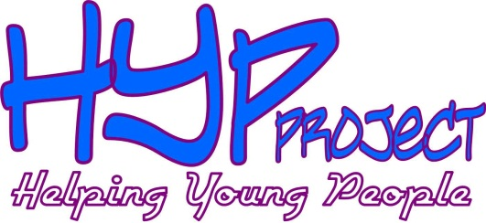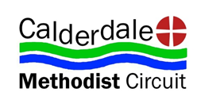Jan 2013 Newsletter
The HYP Project has been running for nearly 18mths now and we have lots that we want to tell you…
Individual Work
I find the most effective way of working with a young person is simply to listen to them. To take time out for somebody else solely for their purpose can often be all they need to help somebody channel what they are thinking or feeling.
With some careful thought, consideration and a certain level of trust, you can really help them to take things to another level and help them to see where they could do things differently and gently challenge; support them through those changes; then help them to reflect on the benefits of those changes.
Group Work
After 18 months working closely in a group setting of young people, HYP is helping to make young people feel valued for who they are as they are. Although we accept them for who they are there are needs within this group that HYP can meet. These are:
- Teaching cooking skills
- Creating volunteering and training opportunities through the One Programme
- Helping them make better life style choices
- Working towards a better self-esteem
- Reducing/stopping drug intake
What’s Happening Soon:
After rewarding a group for giving up substance misuse for a day, the group prepared a day away.
Now we are at the point of taking them away for a weekend with the sole purpose of them giving up substance misuse for the weekend. This is going to be loaded with the intention of pure fun!
Please pray that:
- The group would find it easy without drugs and see an amazing transformation on the weekend away.
- Names of young adults you can pray for are Martha; Leon; Yvette; Ian; Beth; Adam; Jodie; James; Bob; Chris; Ruth; Eddie; Tony; Myself
- The possibility to go away for a week to serve a community overseas
HYP office tel number – 01422 322 774
Mobile: Laura – 07963 123 547
Chris - 07760 409 996

